**Visualizing 120 Years of the Olympic Games**

**Topic**

Our project is focused on providing insight into the Olympic Games. Our final dashboard shows where the Games have been held, and how the Olympics has grown. We will show this through a map of all host cities, and visualizations of the change in participating athletes and represented sports over the years. This project will show how the Olympics is universally popular and continues to evolve through the years.

**Data**

Our dataset, “120 Years of Olympic History: Athletes and Results” was found on kaggle. <https://www.kaggle.com/heesoo37/120-years-of-olympic-history-athletes-and-results>

The data included:

* Athletes (sex, age, height, weight)
* Country (country code, team)
* Sport and Event
* Season
* Year
* Medal Won

**Example Visualizations**

1. Location of Winter Olympics through the years: This visual inspired us to create a map of locations of where all (Summer and Winter) Olympic Games have been held through the years. We will incorporate tooltips on the locations to provide further information on the dates/locations.

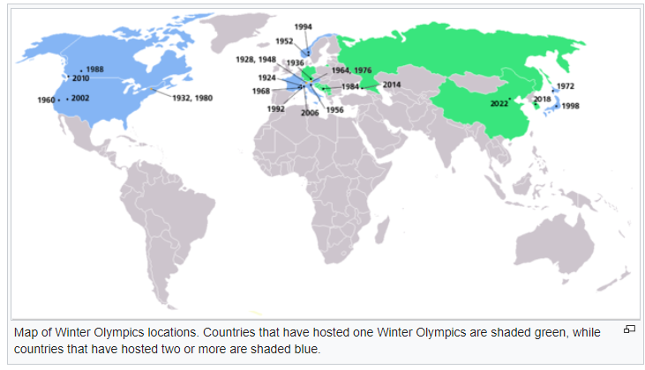

**Final Design**

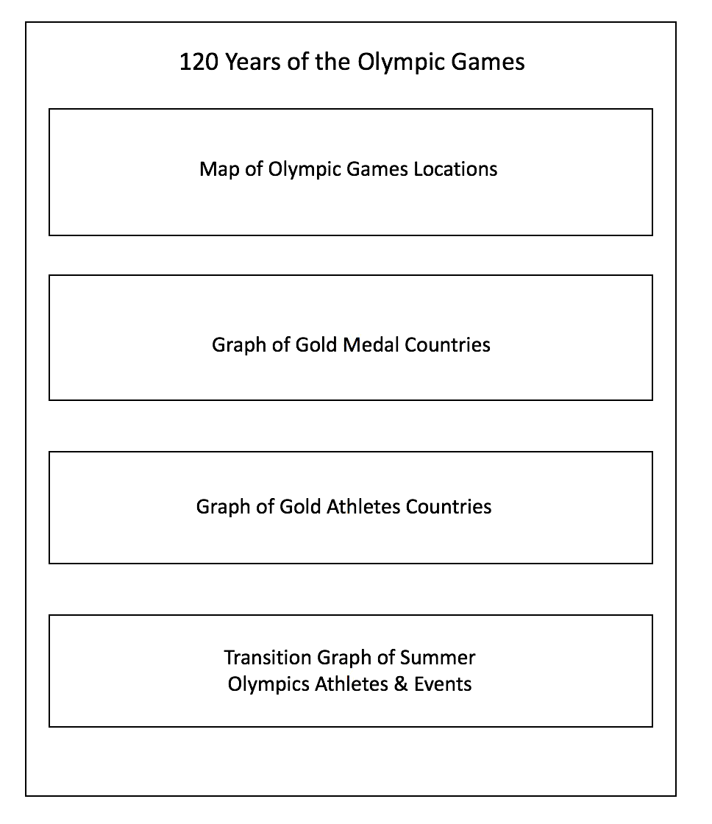

**Github Repository**

https://github.com/kleelee/Olympics_Dashboard